November  December | Winter 2022  Bible Navajo Mission & Wildcat Christian Academy
A New Year Has Arrived

Native American Heritage Month
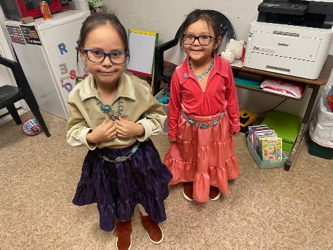

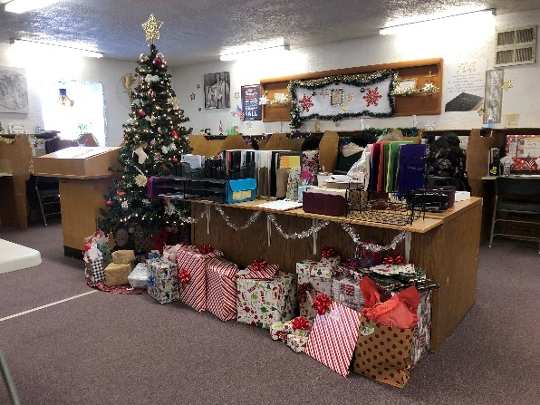 |  | 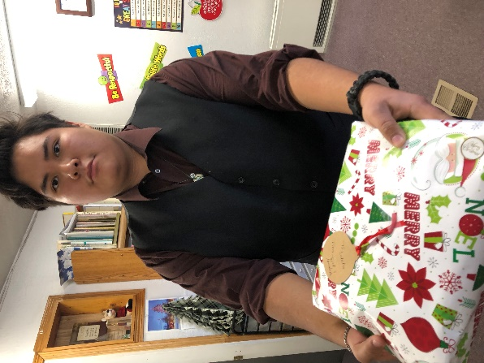 |  |  |  | 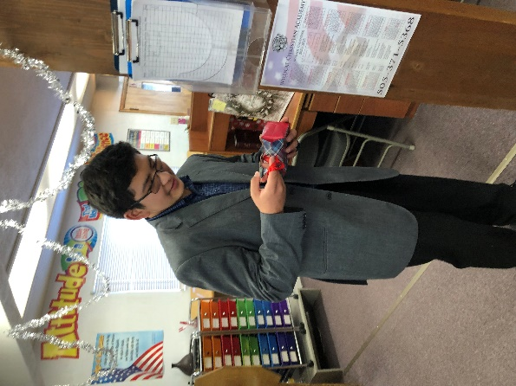
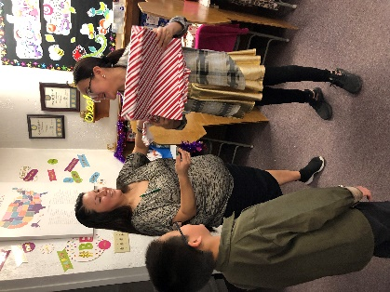 |  |  |  |  |  | 

Christmas Activities
Christmas Program
Almost all our school children participated in our Christmas Program. We presented the play “The Three Trees”. The story told of the birth, life, death and resurrection of our Saviour. We had several performances from our upper learning center students, and our elementary sang Christmas carols. We had about 120 or more at the program, and we pray God will use this to speak to those who attended. We want to give a special thank you to Susan Williams for her special donations to help cover the costs of putting on our program and other Christmas events.

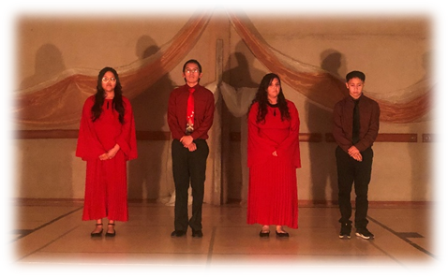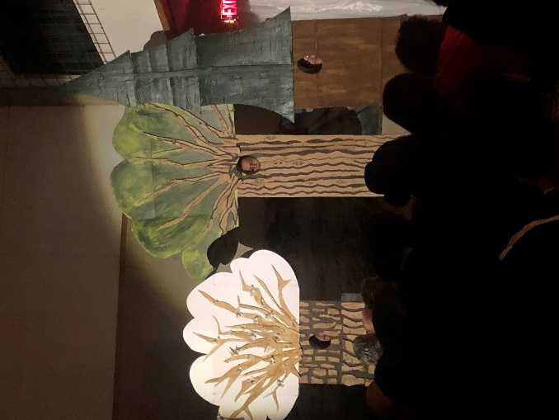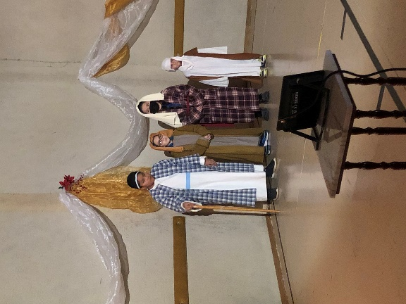 |  | 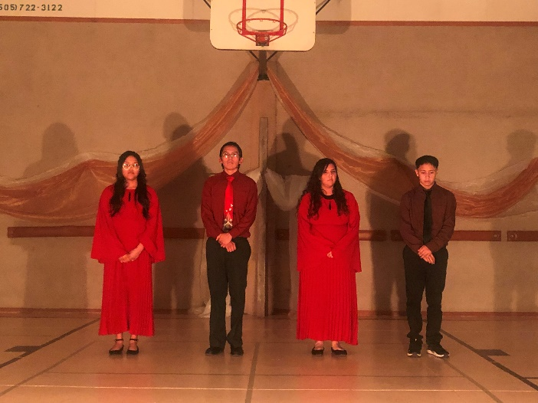  Above: Aaliyah Yazzie, Ethan Joe, Teya Herrick & Angelo Ariviso  presenting “Mary Did You Know” in Sign Language  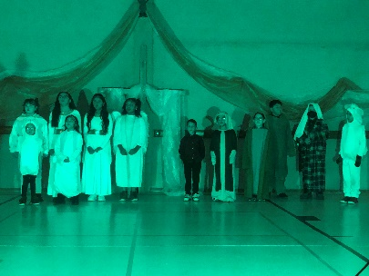  Left:  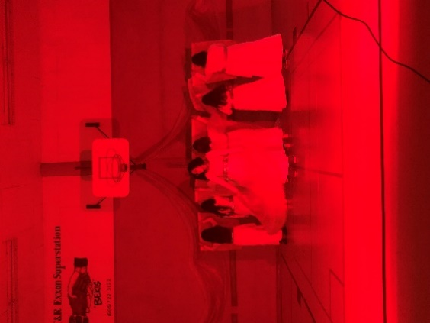  Upper LC girls performing a praise dance with flags |  |  | 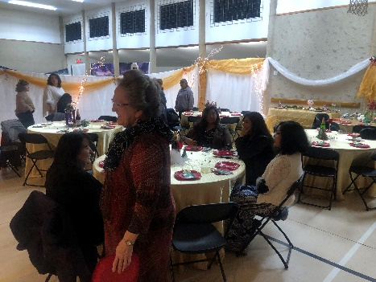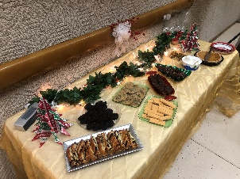  Daughters of the King Women’s Ball  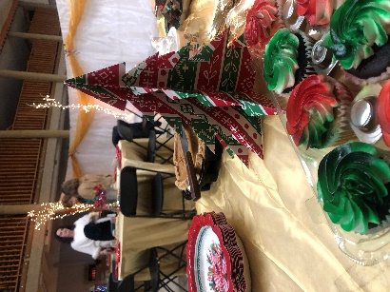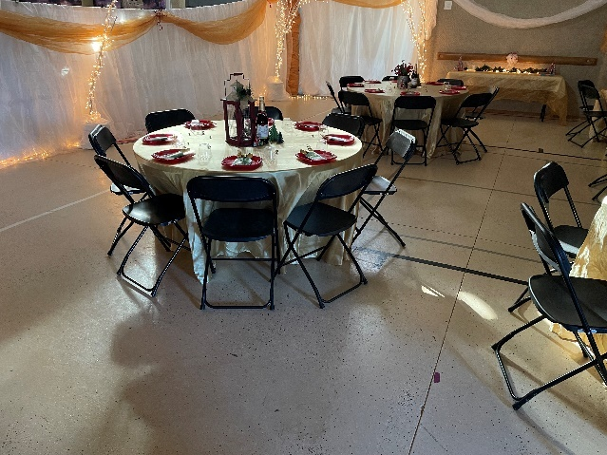
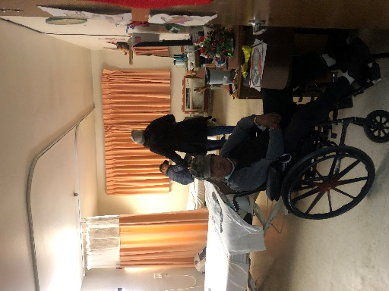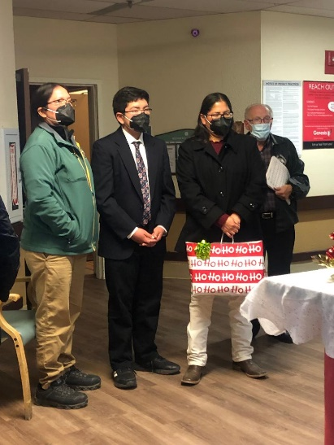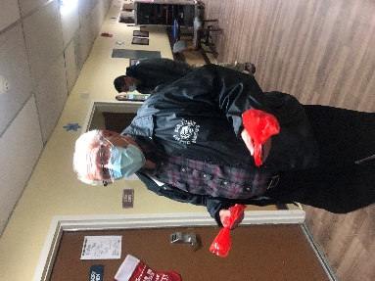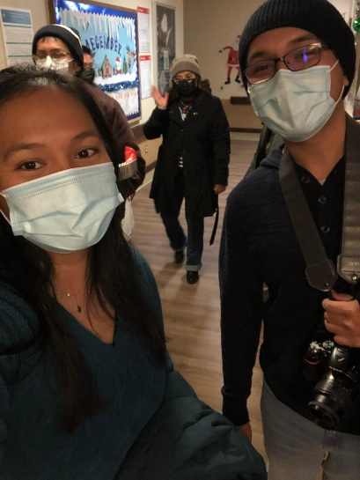 |  |  |  |  | Birthday for Jesus Sunday  “For unto you is born this day in the city of David a Saviour, which is Christ the Lord.”  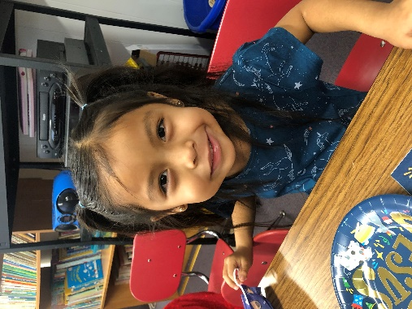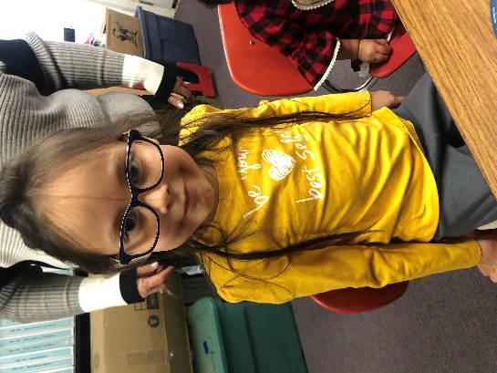  Above: Allie Watchman & Annabelle Chee  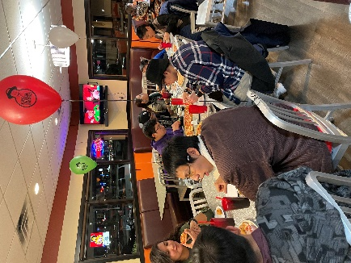  Ignite Youth Group  Thank you to all those who have given to fund our youth group ministries and activities run by Jaime & Tiffany Wato. God has been moving on the hearts of some of the members of the group and we’ve seen growth. Please keep our young adults in your prayers that they can continue to grow spiritually. 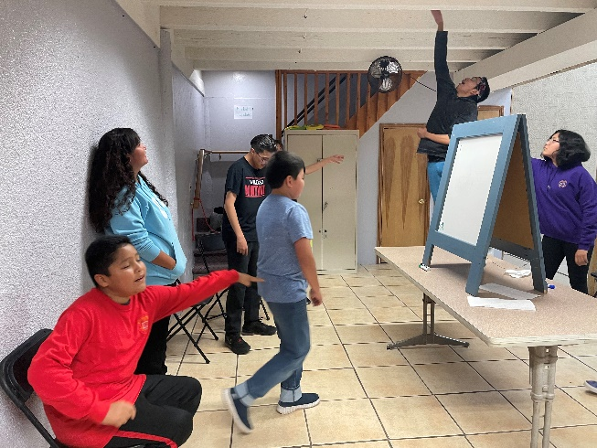
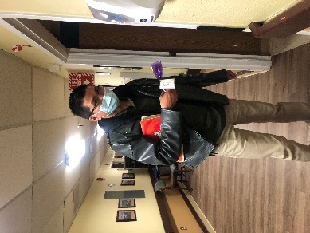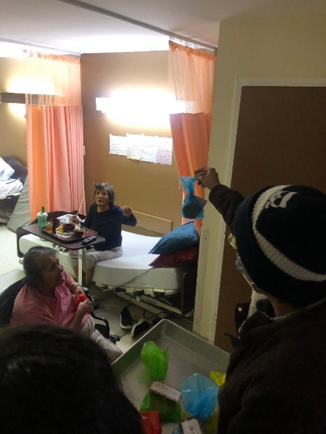 | 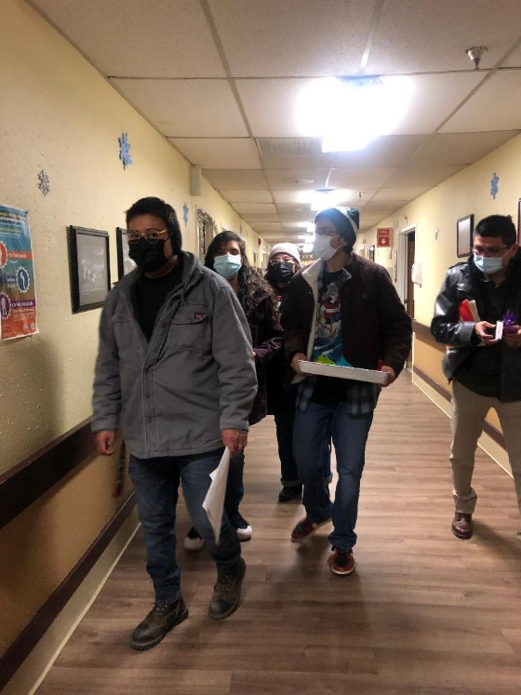
 |  |  | Page 4

School Update  We have a good student body this year once again. There will always be problems, but we are thankful for a peaceful year. We ask for special prayer for a couple students that need the Lord, and deliverance from certain things in their lives. We have had several chapels where different students have given their lives to the Lord or made confessions of differing things in their lives. Our main objective is to give our students the hope of a better life in Jesus Christ and that they would see their need of Him early in their lives.  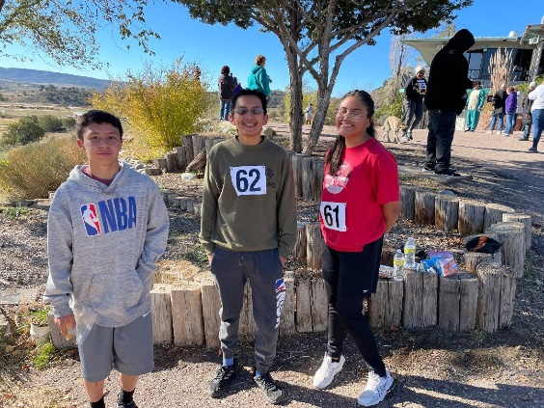  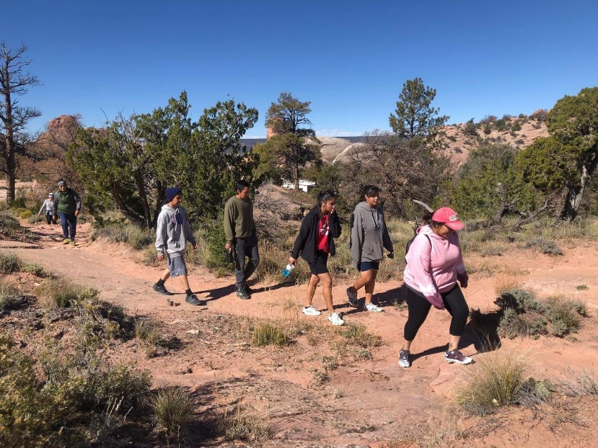 |  |  |  |  | A Note From Anna Bowling  Dear Supporters,  Many thanks for all your wonderful gifts and support throughout the year. We are so thankful for each of you. I would like to give praise to God for the spiritual growth our church has seen within this year. I have seen growth in our members, and those seeking to serve God in the ministry and stepping up to do so. Much love and blessings to each of you in this upcoming new year 2023. God bless you!
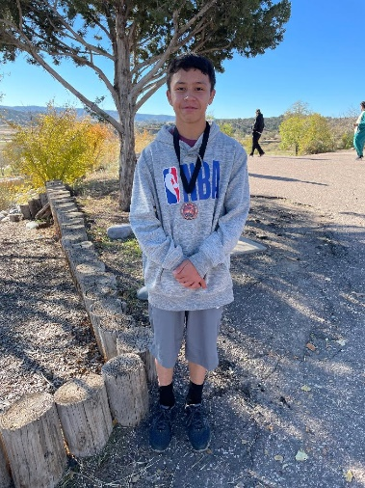
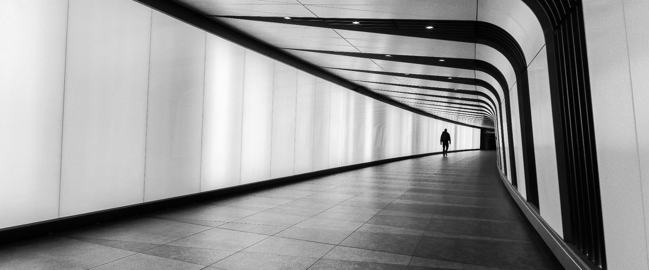
Picture Caption: To make your document look professionally produced, Word provides header, footer, cover page, and text box designs that complement each other.
Mirjam Nilsson

The latest breaking news of the day
The latest updates to get you through the day
To make your document look professionally produced, Word provides header, footer, cover page, and text box designs that complement each other. For example, you can add a matching cover page, header, and sidebar. Click Insert and then choose the elements you want from the different galleries.  Save time in Word with new buttons that show up where you need them.To change the way a picture fits in your document, click it and a button for layout options appears next to it. Themes and styles also help keep your document coordinated. When you click Design and choose a new Theme, the pictures, |  |  | charts, and SmartArt graphics change to match your new theme. When you apply styles, your headings change to match the new theme.  Save time in Word with new buttons that show up where you need them. To change the way a picture fits in your document, click it and a button for layout options appears next to it. When you work on a table, click where you want to add a row or a column, and then click the plus sign. Reading is easier, too, in the new Reading view. You can collapse parts of the document and focus on the text you want.
 |  | Page 7

Tuesday, Sep 20, YYYY |  | NEWS TODAY |  |  |  |  |  | Issue #10
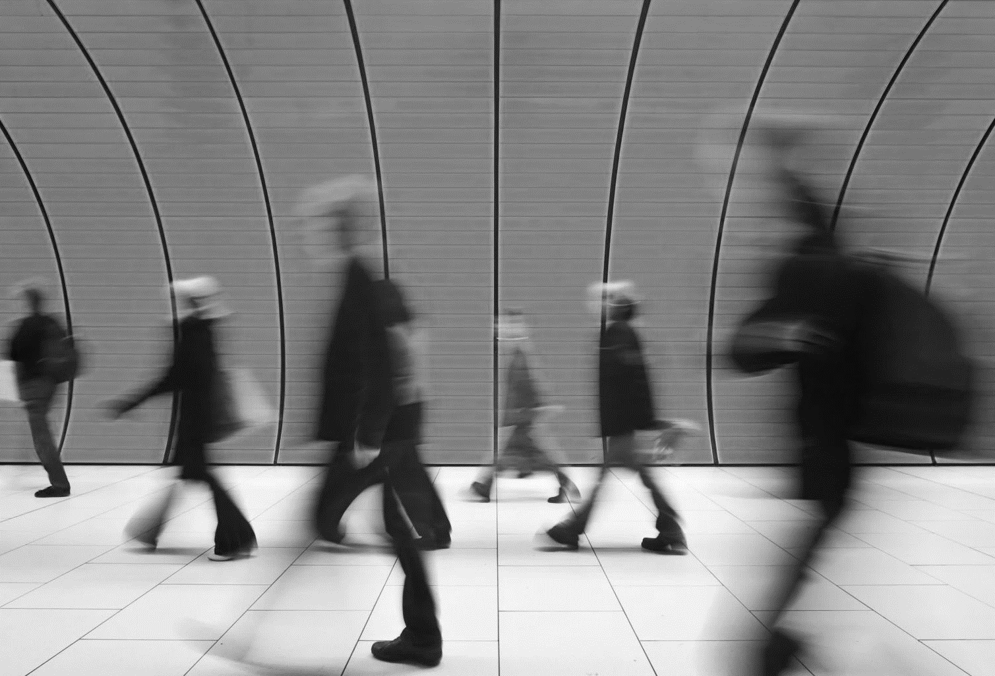
Picture Caption: To make your document look professionally produced, Word provides header, footer, cover page, and text box designs that complement each other.
The latest breaking news of the day
The latest updates to get you through the day
  Mirjam Nilsson | Video provides a powerful way to help you prove your point. When you click Online Video, you can paste in the embed code for the video you want to add. You can also type a keyword to search online for the video that best fits your document. |  |  |  | Save time in Word with new buttons that show up where you need them. To change the way a picture fits in your document, click it and a button for layout options appears next to it. When you work on a table, click where you want to add a row or a column, and then click the plus sign. Reading is easier, too, in the new Reading view. You can collapse parts of the document and focus on the text you want.
To make your document look professionally produced, Word provides header, footer, cover page, and text box designs that complement each other. For example, you can add a matching cover page, header, and sidebar. Click Insert and then choose the elements you want from the different galleries.  Themes and styles also help keep your document coordinated. When you click Design and choose a new Theme, the pictures, charts, and SmartArt graphics change to match your new theme. When you apply styles, your headings change to match the new theme. Save time in Word with new buttons that show up where you need them.  To change the way a picture fits in your document, click it and a button for layout options appears next to it. When you work on a table, click where you want to add a row or a column, and then click the plus sign. Reading is easier, too, in the new Reading view. You can collapse parts of the document and focus on the text you want.  To make your document look professionally produced, Word provides header, footer, cover page, and text box designs that complement each other. For example, you can add a matching cover page, header, and sidebar. |  |  |  |  | “Video provides a powerful way to help you prove your point.”  - Mirjam Nilsson
Video provides a powerful way to help you prove your point. When you click Online Video, you can paste in the embed code for the video you want to add. You can also type a keyword to search online for the video that best fits your document. To make your document look professionally produced, Word provides header, footer, cover page, and text box designs that complement each other. For example, you can add a matching cover page, header, and sidebar.
Click Insert and then choose the elements you want from the different galleries. Themes and styles also help keep your document coordinated. When you click Design and choose a new Theme, the pictures, charts, and SmartArt graphics change to match your new theme.
 |  |  |  | Page 8

